View status
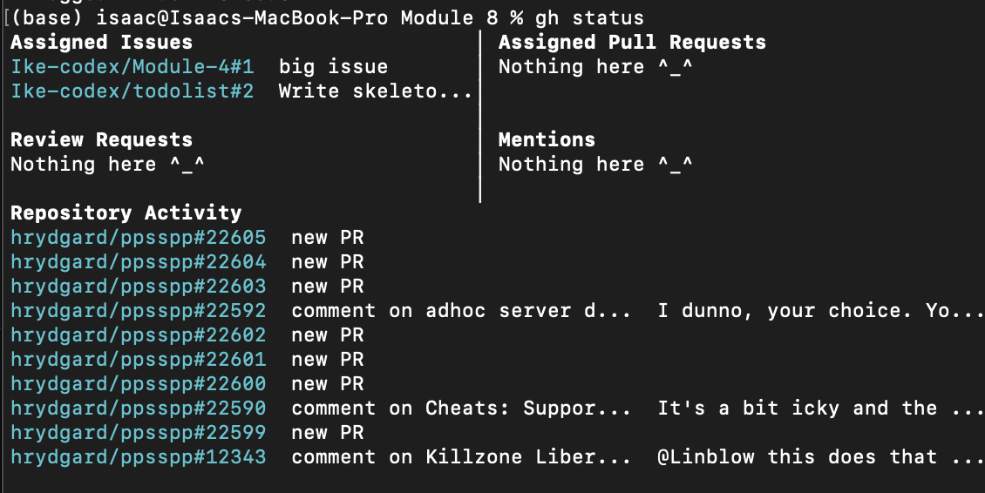
Viewing a repository
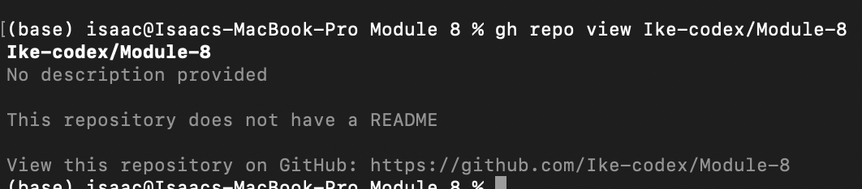
Cloning repository
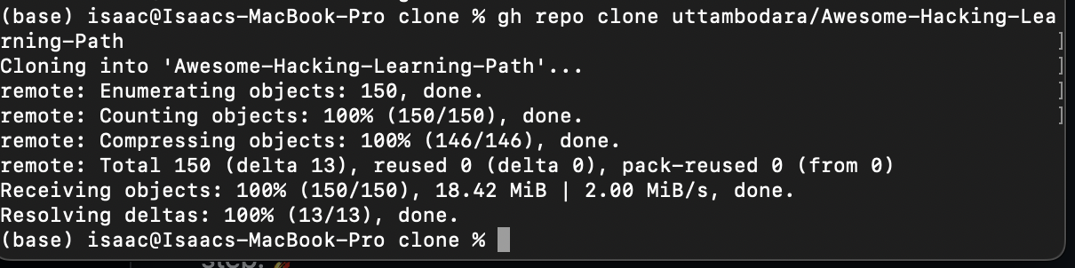
Creating a repository
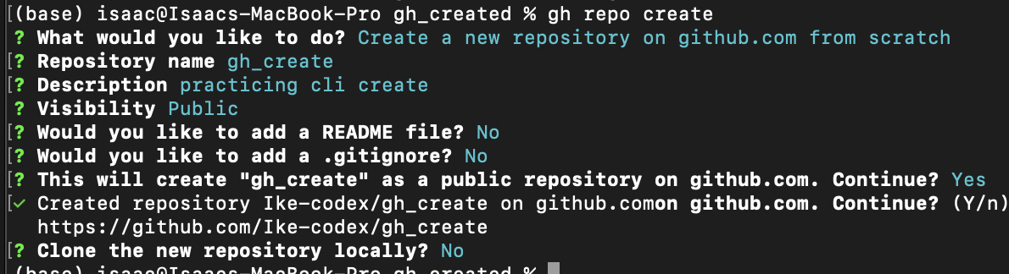
Work with issues
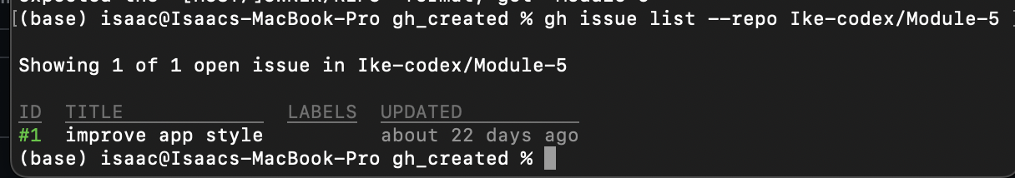
Work with pull requests
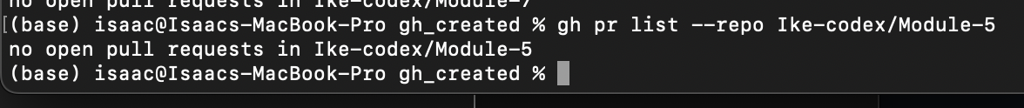
Work with codespaces
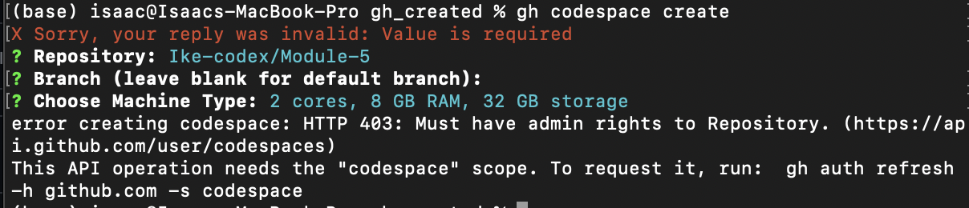
Getting help
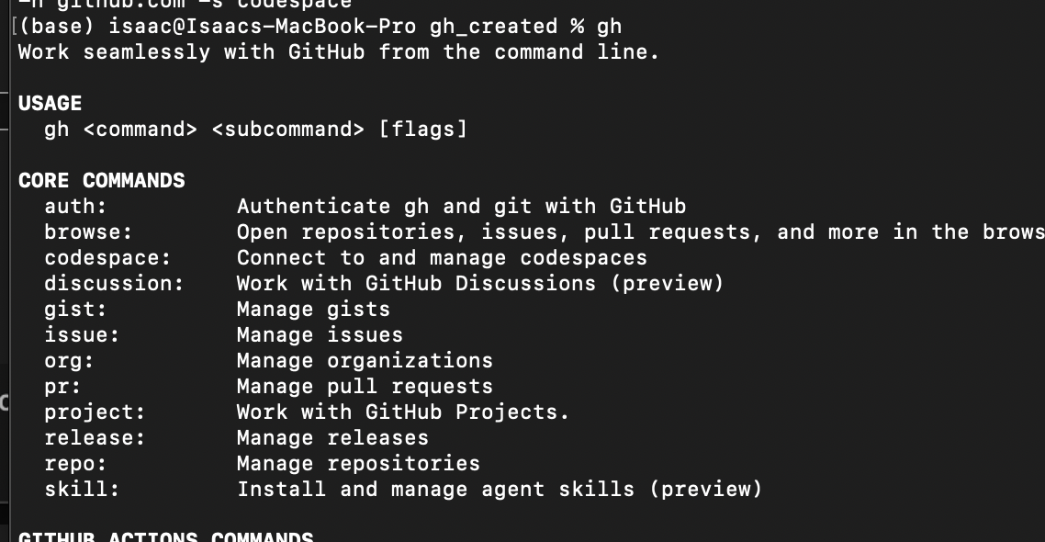
Customizing github cli

